Setting up your Development Environment

A development environment is a combination of a text editor and an interpreter. The text editor allows you to write source code. The interpreter provides a way to execute the code you've written. A text editor can be as simple as Notepad on Windows or more feature-rich as a complete integrated development environment (IDE).

In this course, you will need two free tools to set up your development environment.

1. The Java Development Kit
2. JGrasp IDE (if you are familiar with a different IDE, you are welcome to use it, but all lectures and instructions will be given using JGrasp)

Installing the JDK

The [JDK](https://en.wikipedia.org/wiki/Java_Development_Kit) is what will let us to debug, compile, and run Java code.

Java 9 is currently released, however, there are issues with JDK 9 and JGrasp, so we will be using Java 8 (with no noticeable differences for us).

**Download and install** [**Java 8**](http://www.oracle.com/technetwork/java/javase/downloads/jdk8-downloads-2133151.html)**.**

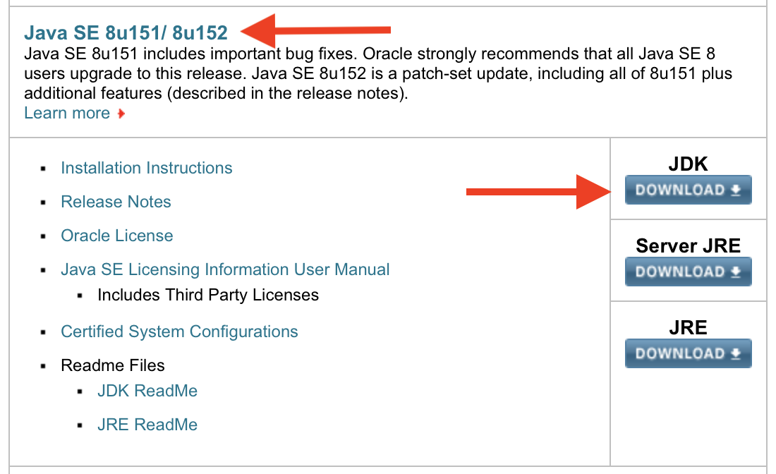

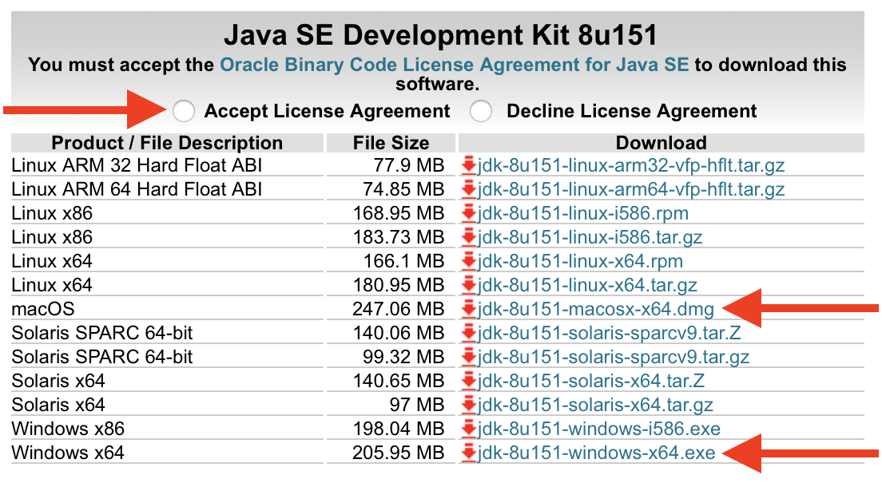

Installing JGrasp

JGrasp is the IDE that we will be using in class. It is lightweight and nice for beginners. There are many, many other IDEs that you are welcome to use (Eclipse, IntelliJ, NetBeans, etc), which have more bells and whistles, but I find them unnecessary for new programmers. Also, our textbook uses JGrasp. :-)

**Download and install** [**JGrasp**](http://spider.eng.auburn.edu/user-cgi/grasp/grasp.pl?;dl=download_jgrasp.html) **(non-beta version).**

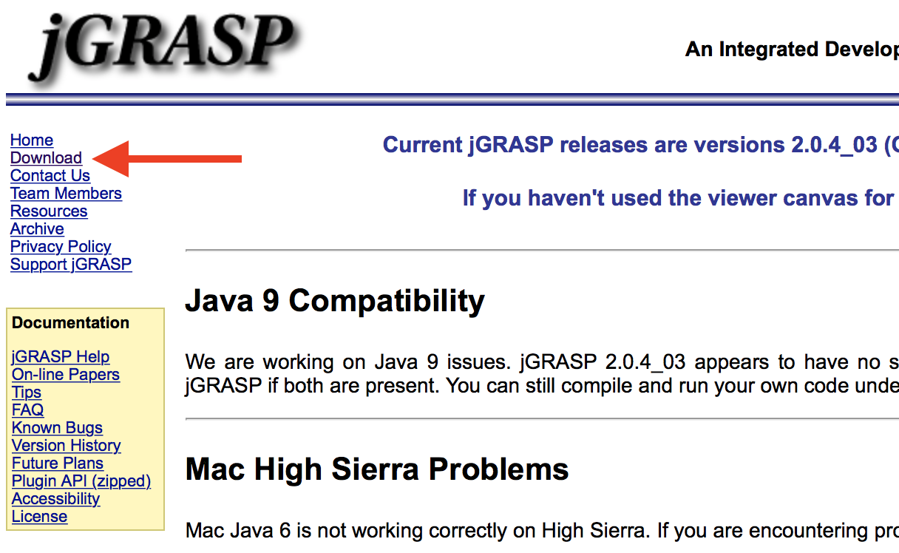

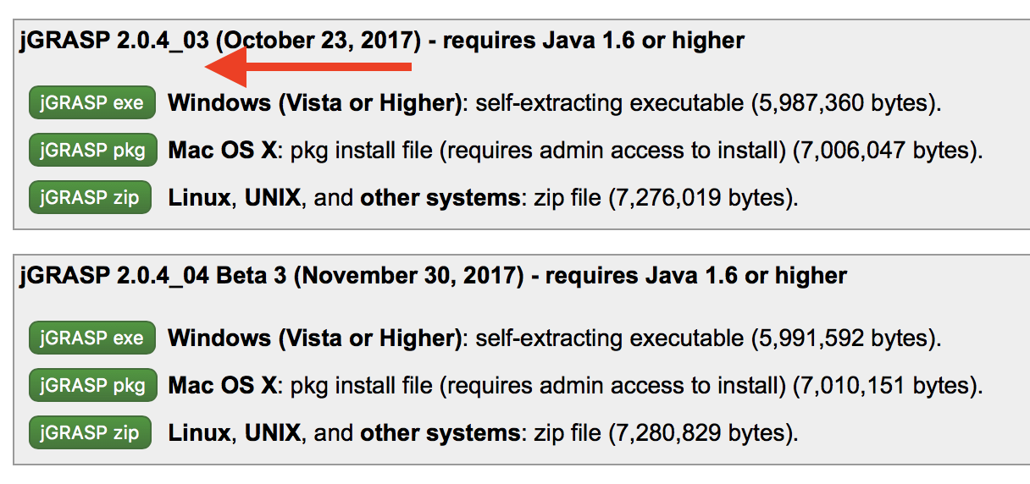

Test it out

To check if your Environment is properly set up:

1. Create a new file (File --> New --> Java)
2. Type the 8 lines of code below.
3. Save the file (accept the suggested name: TestMain.java); you should probably create a folder where you will put all your programs (I named mine CS141 in the example below)
4. Click the green plus sign (approximately under "Help" Menu); this compiles your code. If you have errors, you will need to fix them.
5. Click the red running man; this runs your compiled code.
6. Look in the "Run I/O" section at the bottom and you should see the output of your program.

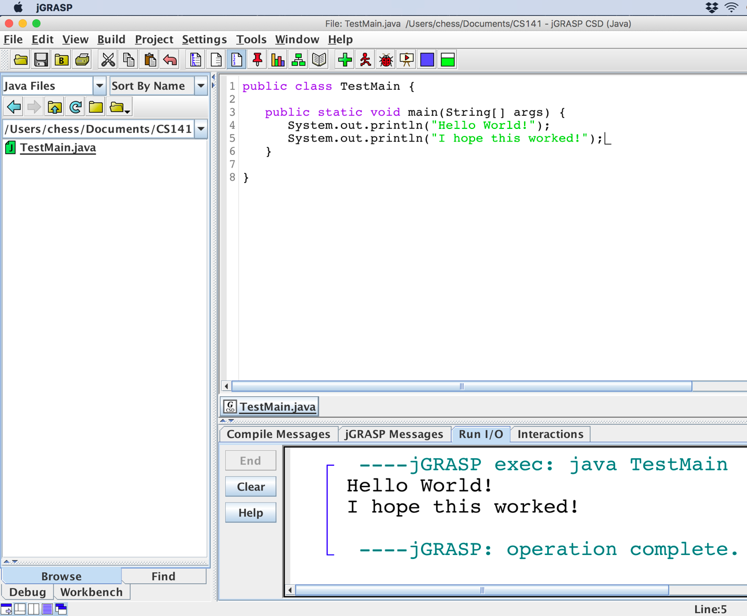

Start writing Java code

Now that you've got your Dev Environment up and running, you can start playing around with writing Java code. There are tons and tons of books and online resources that you can check out or you could grab a copy of our textbook and start working through the examples there.

If you don't have a copy of the textbook yet, you can check out some of the examples given in the first two Chapters slides (we fly through both Chapters 1 and 2 in the first week of class, so an early start won't hurt).

1. [Chapter 1: Introduction to Java Programs](https://shoreline.instructure.com/courses/1558432/files/90753204/download?wrap=1)
2. [Chapter 2: Primitive Data and Definite Loops](https://shoreline.instructure.com/courses/1558432/files/90753203/download?wrap=1)